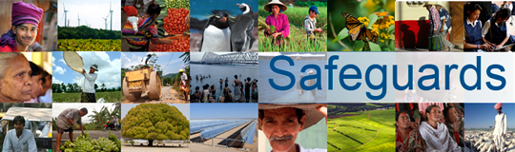
The World Bank
REVIEW and UPDATE of the WORLD BANK’s ENVIRONMENTAL and
SOCIAL SAFEGUARD POLICIES
PARTICIPANTS LIST

Date: 31 January, 2013
Venue: Centralposthuset, Mäster Samuelsgatan 70, 103 33 Stockholm, Sweden
Total Number of Participants: 10

No. | Participant Name | Organization Represented | Organization Type
1 | Stefan Henningsson | WWF | NGO
2 | Kristin Sjöblom | Swedfund | DFI (Development Finance Institution)
3 | Lars-Olle Larsson | Swedfund | DFI (Development Finance Institution)
4 | Carl-Henrik Jacobsson | Diakonia | NGO
5 | Anna Gustafsson | Amnesty International | NGO
6 | Rasmus Klocker Larsen | Stockholm Environment Institute | Think Tank
7 | Karin Isaksson | Sida | Government
8 | Henrik Bergquist | Ministry for Foreign Affairs | Government
9 | Therese Svensson | Ministry for Foreign Affairs | Government
10 | Linda Nilsson | Ministry for Foreign Affairs | Government

