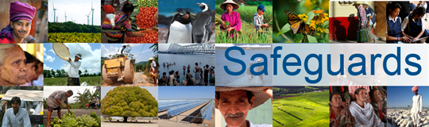
The World Bank
Review and Update of the World Bank’s Environmental and
Social Safeguard Policies

Consultation Meeting with Civil Society Organizations - Participant List
Date: March 21, 2013
Venue: Cairo, Egypt
Total Number of Participants: 25
No. | Participant Name | Title/Organization Represented
1 | Tarek El Baz | UN Consultant
2 | Mohamed Samir | Institute of National Planning (INP) - Professor of Economics
3 | Hany Samir | Egyptian Federation of Independent Trade Unions (EFITU)
4 | Heba Shaaban | World Bank Consultant
5 | Abdel Mawla Ismail | Egyptian Association for Collective Rights (EACR)
6 | Clavera Beucowo | Ford Foundation
7 | Angelina Jarouj | Bank Information Center
8 | Kateryn Gallagher | Bank Information Center (BIC)
9 | Samar Youssef | Forum of Dialogue and Partnership for Development (FDPD) Manager
10 | Amr Lashin | Governance Program Manager - CARE
11 | Mariam Fadel | Solidarity Center
12 | Raouf Okasha | Professor
13 | Mohamed Abd El Azim | Egyptian Center for Civil and Legal Reform
14 | Ahmed Azarara | Egyptian Initiative for Personal Rights
15 | Ahmed El-Dorghamy | Energy & Environment Consultant
16 | Aysara Fouad | MIFT - CI Expert
17 | Amy Ekdawi | Manager, Bank Information Center
18 | Habiba Ramdan | Research Assistant, Egyptian Center for Economic and Social Rights
19 | Mahinour El Badrawi | Programs Officer, Egyptian Center for Economic and Social Rights
20 | Yahia Shawkat | Housing Right Researcher, Egyptian Initiative for Personal Rights
21 | Ziad A. Amer | Kayan Community Building, General Director
22 | Laila Iskandar | Community and Institutional Development (CID) Consulting
23 | May Zein ElDein | CEO & Founder - Al Hassan Foundation
24 | Dr. Iman Karim | Founder - Al Hassan Foundation
25 | Jamr Youseif | Professor

