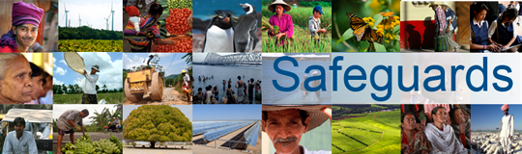
The World Bank
Review and Update of the World Bank’s Environmental and Social Safeguard Policies

Consultation Meeting – Participant List
Date: December 3, 2012
Venue: World Bank Paris Office (French government stakeholder meeting)
Total Number of Participants: 8

No. | Participant Name | Department/Division | Ministry/Agency Represented
1 | Frédéric Glanois, Head of Office | ODA and Multilateral Development Institutions, Treasury Directorate-General | Ministry of Economy and Finance
2 | Aurélien Billot, Deputy Head of Office | ODA and Multilateral Development Institutions, Treasury Directorate-General | Ministry of Economy and Finance
3 | Catherine Garetta, Director | Cross-Operational Issues and Support | Agence Française de Développement (AFD)
4 | Jean-Noël Roulleau, Manager | Operational Support for Social and Environmental Issues | AFD
5 | Myriam Hammami, Officer for Bilateral and Multilateral Banks | External Relations | AFD
6 | Raphaël Martinez, Head of Office for Multilateral Development Institutions | International Economic Affairs, Directorate-General for Global Affairs | Ministry of Foreign and European Affairs
7 | Alison Laclau, Officer for World Bank and IMF | International Economic Affairs, Directorate-General for Global Affairs | Ministry of Foreign and European Affairs
8 | Diane Beaulieu-Milisavljevic, Officer for Multilateral Development Banks | International Affairs | Ministry of Ecology, Sustainable Development, and Energy

