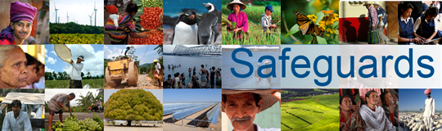
The World Bank

Review and Update of the World Bank’s Environmental and Social Safeguard Policies

Consultation Meeting – Participant List

Date: December 3, 2012
Venue: World Bank Paris Office (Civil society and academic stakeholders meeting)
Total Number of Participants: 6

No. | Participant Name | Organization/Institution Represented | Organization Type | Country
1 | Dominique Guillaud | Institut de Recherche pour le Développement (IRD) | Academic research institute | France
2 | Reiko Hasegawa | Institut du Développement durable et des Relations internationales (IDDRI) | Academic research institute | France
3 | Edina Ifticene | WWF France | NGO | France
4 | Alexandre Côte | International Disability Alliance (Secretariat) | NGO | France
5 | Carolin Vollmann | International Trade Union Confederation (ITUC) | Trade union confederation | Belgium
6 | David Pred | Inclusive Development International | NGO | US/Cambodia

