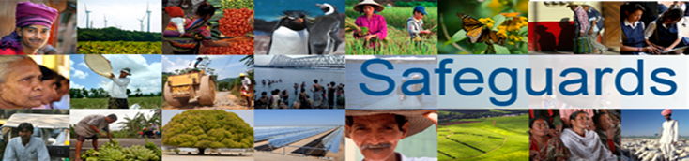

The World Bank
REVIEW and UPDATE of the WORLD BANK’s ENVIRONMENTAL
and SOCIAL SAFEGUARD POLICIES
Multi-Stakeholder Consultation Meeting
- Government Offices, Mäster Samuelsgatan 70, Stockholm, Sweden-

A multi-stakeholder meeting was held on January 31, 2013 to discuss the World Bank Safeguards review and update process as well as the Asian Development Bank’s Compliance and Accountability Mechanism. The meeting was chaired by the Ministry for Foreign Affairs and included participants primarily from civil society organizations (see Annex 1).
Comments and questions from the participants directed to the World Bank included the following:
- The World Bank should address ecosystem services in the Safeguards framework.
- CSO participant Diakonia made reference to the “Joint Letter and Submission to President Kim Re. World Bank Safeguards Review,” which it had signed.
- Adequate budget and staff are currently lacking to enable appropriate monitoring and implementing of the Safeguards.
- Will impact assessments of conflict be part of the updated safeguards, that is, how businesses and government systems function within conflict-affected areas?
- Participants praised the Turn Down the Heat report as well as Jim Kim’s statement “We will never end poverty if we don't tackle climate change.”
- How will power production be addressed? Will coal-fired power plant investments be revisited? Does the Bank integrate emission standards such as CO₂ per kw or use of latest/best technology in its projects?
- The updated Safeguards should include a comprehensive human rights policy – or at least include a compulsory human rights due diligence process to be undertaken by both the Bank and its clients – and ensure it is in line with international standards. More precisely, the policy regarding Indigenous Peoples should be aligned by the UN Declaration on the Rights of Indigenous Peoples (UNDRIP) and other applicable international standards, especially with regard to FPIC, displacement and resettlements, and forced evictions, for which an explicit prohibition should be made.
- With reference to the Asian Development Bank’s policy allowing for cases to be put to their accountability mechanism up to two years after the loan/grant closing date, participants asked what the deadline is for filing complaints with the World Bank Inspection Panel.
- What will the real outcome be ten years after having reviewed the Safeguards policies? Will the Bank be able to reject fossil fuel?
- How does the Bank validate government documents to satisfy itself that proper procedure and process is followed by, for example, the Environmental Impact Assessment (EIA)? In many cases, country governments and counterpart agencies lack capacity, monitoring systems and evaluation systems. In the case of EIAs, required verification missions and public consultations may not have been undertaken or audited by government agencies. To what extent does the Bank have a generic independent assessment as a second level of control and how much trust does the Bank put in governments’ own documentation? The importance of the rigour in the preventive measures in the Bank’s safeguards is particularly evident since the material (on past complaints) presented by the Bank shows that when a complaint is subsequently brought forward then the likely outcome will be a negotiated compensation rather than rectifying the damage through rejecting a project or backtracking it.
- Are individual staff held accountable when Bank-funded projects do not meet safeguard standards or other operational policies?
- Participants were sceptical of the use of country systems and questioned their use within the Safeguards framework.

Annex 1
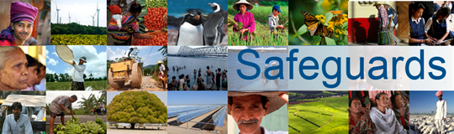
The World Bank
Review and Update of the World Bank’s Environmental and Social Safeguard Policies
Consultation Meeting – Participants List

Date: 31 January, 2013
Venue: Centralposthuset, Mäster Samuelsgatan 70, 103 33 Stockholm, Sweden
Total Number of Participants: 10

No. | Participant Name | Organization Name | Organization Type
1 | Stefan Henningsson | WWF | NGO
2 | Kristin Sjöblom | Swedfund | DFI (Development Finance Institution)
3 | Lars-Olle Larsson | Swedfund | DFI (Development Finance Institution)
4 | Carl-Henrik Jacobsson | Diakonia | NGO
5 | Anna Gustafsson | Amnesty International | NGO
6 | Rasmus Klocker Larsen | Stockholm Environment Institute | Think Tank
7 | Karin Isaksson | Sida | Government
8 | Henrik Bergquist | Ministry for Foreign Affairs | Government
9 | Therese Svensson | Ministry for Foreign Affairs | Government
10 | Linda Nilsson | Ministry for Foreign Affairs | Government

