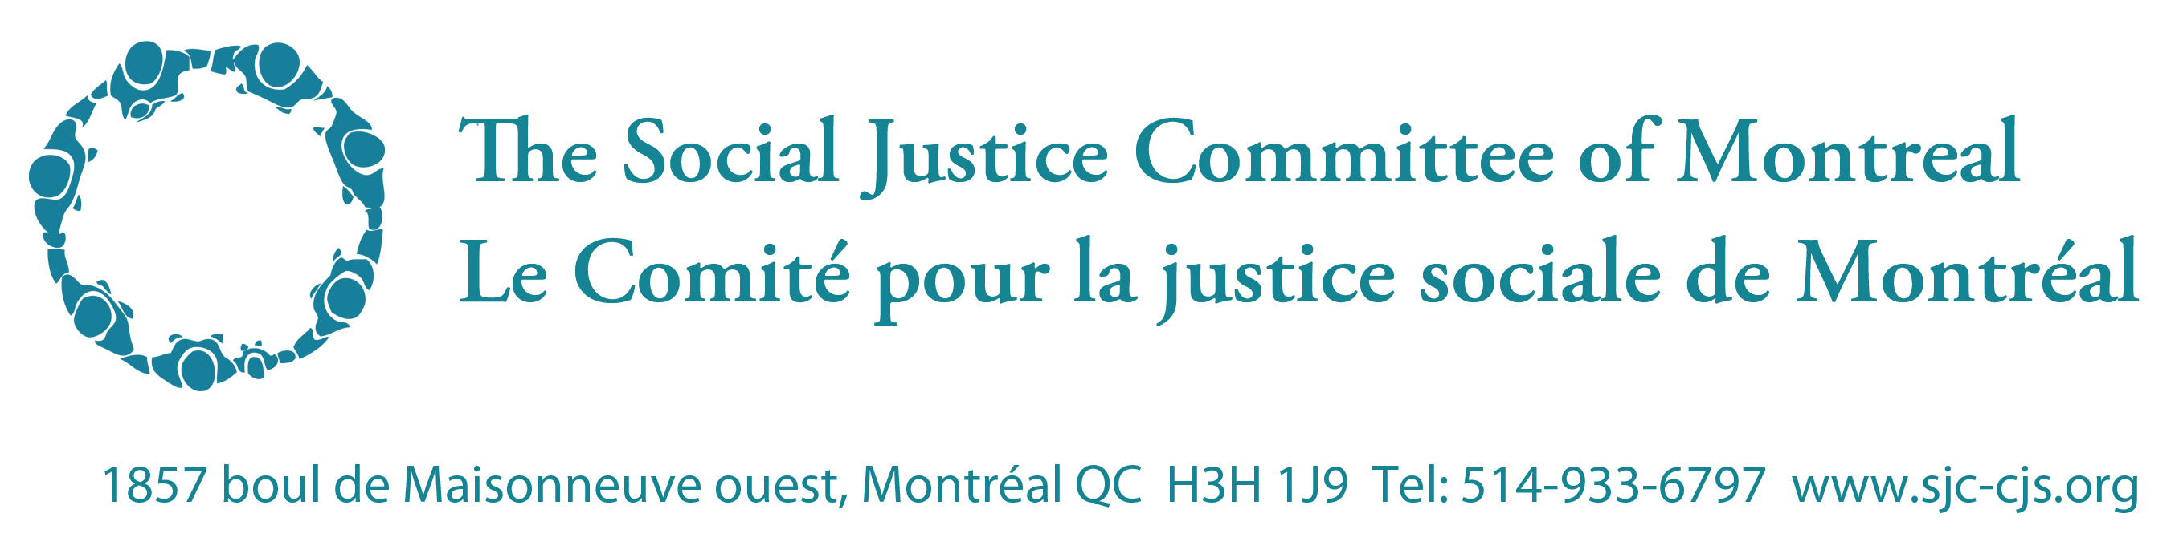

April 2013

Recommendations from the Social Justice Committee of Montreal to the World Bank safeguards review
World Bank safeguards should reflect the endorsement of a human rights-based approach to development and compliance with international human rights law.

International agreements on human rights law are part of international law, providing a well-developed set of codes of conduct that must be respected. Complying with these laws should not be a matter of convenience, but must inform all actions on an international scale. The failure of the World Bank to explicitly recognize the obligations that are imposed by international law is a major failing, one that allows not only the Bank to ignore rights abuse when it does its project assessments but indeed works to provide funding support to rights abuse.
World Bank safeguards should be explicitly framed to encourage and strengthen the understanding, support and promotion of international human rights law. This is mainly defined in terms of human rights treaties. International law on human rights has been well developed since the 1948 Universal Declaration of Human Rights. There are nine core international human rights treaties, some of which are supplemented by optional protocols dealing with specific concerns.
Through the safeguards policy, the World Bank Group should:
- Commit to respect for international human rights law, and incorporate international legal standards in policy texts where relevant.
- Make clear to borrowers the Bank’s role under international law, and the extent to which that relates to the obligations of the individual borrower.
- Assist borrowers to realize their international law obligations, and provide assistance in implementing and enforcing international conventions to which they have agreed.
The World Bank should not attempt to develop a new set of social standards without recognizing the primacy of existing law. The challenge for the Bank as it refines its safeguard policies is to devise ways by which it can support and promote compliance with international human rights law.

Canada’s law on human rights in ODA, and its implications for Canada as a donor

Canada gives over $1 billion annually to the World Bank Group through IDA and other trust funds subject to Canada’s Official Development Assistance Accountability Act, which requires that the initiatives contribute to poverty reduction, take into account the perspectives of the poor, and are consistent with international human rights standards.

The lack of a comprehensive human rights policy at the Bank would seem to have relevance to this funding. The Government of Canada needs to be able to demonstrate that its funding is compliant with this Act, and the absence of a human rights policy should be cause for concern that this funding is not in compliance and thus in violation of national law.

Supplemental views:

The policy of the government of Canada on international human rights is clear about their role in development:
“Canadians recognise that their interests are best served by a stable, rules-based international system. Countries which respect the rule of law tend to respect the rights of their citizens, are more likely to benefit from development, and are much less likely to experience crises requiring peacekeeping, emergency assistance or refugee resettlement missions. “

UN Special Rapporteur on adequate housing Raquel Rolnik also noted the importance of rights in development:
“The World Bank should adopt safeguards policies aligned with the international human rights obligations of its member States and clients. Incorporating human rights protections will help member States fulfil their human rights obligations and improve development outcomes by ensuring respect for the rights of those the Bank seeks to benefit.”

Additional note - The relevance of the Dañino opinion:
The 2006 “Legal Opinion on Human Rights and the Work of the World Bank” by Roberto Dañino, Senior Vice-President and General Counsel, recognized that the evolution of Bank policy to include human rights is a necessary, appropriate and positive step that should be taken:
The Bank has accepted that issues of governance are relevant for purposes of economic analysis and it is now widely recognized that there are a host of factors including social, environmental and political elements that may affect economic growth. The Bank should therefore rely upon an analysis of all the factors that can affect its investments and other activities including a comprehensive perspective of the country conditions. Indeed, in the private sector this kind of analysis is standard practice. Reliance on a broad set of factors in economic analysis is supported by a burgeoning literature, including research suggesting a correlation between respect for human rights and economic outcomes. Some of this research has shown that substantial violations of political and civil rights are related to lower economic growth.

The Bank has a significant role in helping member countries in the substantive realization of their human rights obligations in areas that fall within the remit of its mandate and where development activities and human rights are deeply interrelated.

Where violations or non-fulfilment of obligations are at issue, and where these have an economic impact, the Bank should take these into consideration. Furthermore, if a human rights violation leads to a breach of international obligations relevant to the Bank, such as those created under binding decisions of the UN Security Council, the Bank should also take those violations into account.

In egregious situations, where extensive violations of human rights reach pervasive proportions, the Bank should disengage if it can no longer achieve its purposes.

