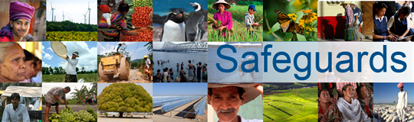
Review and Update of the World Bank’s Environmental and Social Safeguard Policies

Phase 2
Multi-stakeholder consultation at the Civil Society Forum of the Annual Meetings

October 11, 2014
9am – 12.40pm
World Bank I-Building, I2 – 220
1850 I St NW, Washington, DC

9:00 –9:10 AM Welcoming Remarks
Stefan Koeberle, Director, Operations Risk Management

9:10 – 9:20 AM Consultation Meeting Process and Housekeeping
Sumir Lal, Director, Global Practices Communications

9:20 –9:50 AM Presentation on the Proposed Environmental and Social Framework
Mark King, Chief Environmental and Social Standards Officer

9:50-10:00 AM Clarification Questions

10:00-10:20 AM Discussion: Non-discrimination

10:20-10:40 AM Discussion: Labor and Working Conditions

10:40-11:00 AM Discussion: Indigenous Peoples

11:00-11:20 AM Discussion: Land and Involuntary Resettlement

11:20-11:40 AM Discussion: Biodiversity

11:40-12:00 PM Discussion: Human Rights

12:00-12:20 AM Discussion: Adaptive Risk Management

12:20-12:30 AM Wrap-up and Next Steps
Sumir Lal, Director, Global Practices Communications

