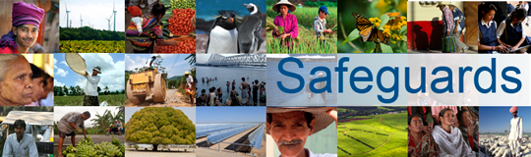
Review and Update of the World Bank’s Environmental and Social Safeguard Policies

Phase 3

List of participants

Date: December 8, 2015
Location: Dushanbe, Tajikistan (World Bank Country Office)
Audience: Ministries, PIUs
Total Number of Participants: 15

No. | Participant Name | Organization/Position | Country
1 | Abdulloev Umarali | Central Asia Hydrometeorological Project/Component C, Technical Manager | Tajikistan
2 | Abdurahimov Jumakhon | Ministry of Health, Deputy Head of the State Sanitary and Epidemiological Surveillance | Tajikistan
3 | Nosirova Tojinisso | Second Public Employment for Sustainable Agriculture and Water Resources Management Project, Consultant for Environmental Protection | Tajikistan
4 | Salomat Nazarova | Committee on Environment Protection, Consultant for Social and Gender Development Project | Tajikistan
5 | Afghonova Idigul | Ministry of Education and Science, Lawyer/Chief Specialist | Tajikistan
6 | Shoev Abdurahim | Ministry of Education and Science, Chief Specialist for Capital Construction Unit | Tajikistan
7 | Talbov Parviz | Global Partnership for Education Project-4 (GPE-4), Assistant for Coordinator | Tajikistan
8 | Valiev D | Ministry of Transport, Deputy Head of the Analysis and Economic Department | Tajikistan
9 | Khomidov Q | Ministry of Transport, Specialist on Ecology | Tajikistan
10 | Karimov M | State Committee for Land Management and Geodesy, Monitoring Specialist | Tajikistan
11 | Mahaidinova Dilfuza | Open Joint Stock Company Barki Tojik, Chief Specialist of the Department of Procurement and Monitoring | Tajikistan
12 | Rajabov Rajabali | Ministry of Labor, Migration and Employment, Head of Labor and Living Standards Department | Tajikistan
13 | Shokirova Marifat | Ministry of Labor Migration and Employment, Deputy Head of International Relations and Public Relations | Tajikistan
14 | Rahimova Rano | Ministry of Health and Social Protection, Head of International Department | Tajikistan
15 | Muminov Mirali | Ministry of Health and Social Protection, Chief Specialist for Monitoring | Tajikistan

