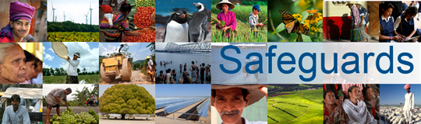
Review and Update of the World Bank’s Environmental and Social Safeguards Policies

Phase 3

Multi-stakeholder Consultation
Rwanda - Kigali
January 15, 2016
Total Number of Participants: 22

No. | Participant Name | Position | Organization | Country
1 | Patrick Wajero | Country Director | OXFAM | Rwanda
2 | Annette | Program Officer | RWN | Rwanda
3 | Mutoni Dianah | Auditoria Assistant | UR (CBE) | Rwanda
4 | Daniel G. Mahz | Admin Officer | PAJER | Rwanda
5 | Parsa Ahmad | Co-Manager | BTC | Rwanda
6 | Josephine Kamarebe | Program Manager | HDI (Health Devp. Initiative) | Rwanda
7 | Safari Emmanuel | Executive Secretary | CLADHO | Rwanda
8 | Francine Umurungi | Advocacy Coordinator | Transparency International Rwanda | Rwanda
9 | Kabandana Antoine | Project Coordinator | RISD | Rwanda
10 | Annie Kairaba | Director | RISD | Rwanda
11 | Kwizera Alphonse | Ass Executive Director | Rwanda Ass. of Manufacturers | Rwanda
12 | Prosper Dutonyekumana | Business Development Officer | YES Rwanda | Rwanda
13 | Pelagie Niwemfura | Policy Research and Advocacy | YES Rwanda | Rwanda
14 | Muramira Bernard | Executive Director | Strive Foundation Rwanda | Rwanda
15 | Philbert Nsegiyumva | Program Manager | Albertine Rift Conservation Society | Rwanda
16 | Karekezi | DAF |  | Rwanda
17 | Businge Anthony | Executive Secretary | AJPRODHO-JIJUKIRWA | Rwanda
18 | Butera Michael | Project Coordinator | RCSP | Rwanda
19 | Zacharie Ndayishimiye | Program Officer | Legal Aid Forum | Rwanda
20 | Murungi Peace | Executive Secretary | RCSP | Rwanda
21 | Stany Ngarukiye | Program Manager | CLADHO | Rwanda
22 | Mukombozi Bonny | Researcher |  | Rwanda

