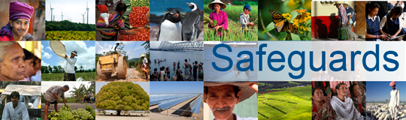
The World Bank
Review and Update of the World Bank’s Environmental and Social Safeguard Policies

Consultation Meeting – Participant List
Date: December 4, 2012
Venue: Infosenter at Norad, Ruseløkkvn 26, 0251 Oslo, Norway
Total Number of Participants: 28
No. | Participant Name | Organization Represented | Organization Type
1 | Erik Helland-Hansen | Norconsult | Private sector
2 | Kevin C.R. Burton | Norconsult | Private sector
3 | Ingvild Reymert | Norwegian Church Aid (NCA) | NGO
4 | Elin Fjestad | The Atlas Alliance | NGO
5 | Ronny Hansen | Rainforest Foundation Norway | NGO
6 | Ingrid Harvold Kvangraven | The Norwegian Coalition for Debt Cancellation (Slettgjelda) | NGO
7 | Gina Ekholt | The Norwegian Coalition for Debt Cancellation (Slettgjelda) | NGO
8 | Dona Hoxha | FIAN Norway (FoodFirst Information and Action Network) | NGO
9 | Tom Henning Bratlie | FIAN Norway (FoodFirst Information and Action Network) | NGO
10 | Trond Sæbø Skarpeteig | FIAN Norway (FoodFirst Information and Action Network) | NGO
11 | Hans Morten Haugen | Forum for Environment and Development | NGO
12 | Ane Schjolden | Forum for Environment and Development | NGO
13 | Nikolai Ostrat Owe | Guarantee Institute for Export Credits (GIEK) | Government
14 | Ivar T. Jorgensen | Norad | Government
15 | Giske C.Lillehammer | Norad | Government
16 | Hans Olav Ibrekk | Norad | Government
17 | Parvez Kapoor | Norad | Government
18 | Livia Costa Kramer | Norad | Government
19 | Evelyn Hoen | Norad | Government
20 | Knut Gakkestad | Norad | Government
21 | Margot Skarpeteig | Norad | Government
22 | Ingrid Marie Mikelsen | Ministry of Foreign Affairs | Government
23 | Bjørn Brede Hansen | Ministry of Foreign Affairs | Government
24 | Harriet Solheim | Ministry of Foreign Affairs | Government
25 | Claudia Melim-Mcleod | UNDP Oslo Governance Center | Multilateral
26 | Tina Hageberg | UN REDD | Multilateral
27 | Marianne Johansen | Ministry of Environment | Government
28 | Johan Tingulstad | Statkraft | State owned energy company

