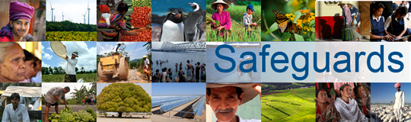
The World Bank
Review and Update of the World Bank’s Environmental and
Social Safeguard Policies

Consultation Meeting with Government Representatives – Participant List
Date: March 25, 2013
Venue: Rabat, Morocco
Total Number of Participants: 16
No. | Participant Name | Participant Title | Organization Represented
1 | Mohamed Ait Khouya | Chief Engineer | Ministry of Transport
2 | Najat Saidou | Head of Environment Studies Department | ONEE - Branche Eau
3 | Omar Ahl Rachid | Head of Studies and Planning department | Ministry of Solidarity, Woman, Family and Social Development
4 | Zakariae El Yacoubi | Chef du service de l'Economie d'Eau | Ministry of Agriculture and Fisheries
5 | Ahlam Zitan | Project Manager | Agence de Development Social (ADS)
6 | Omar Benyaich | Legal Department | Office regional de la mise en valeur de l'agriculture (ORMVA) dans la region du Haouz
7 | Abdessamad Moreno | Environment Specialist | ORMVA du Haouz
8 | Mohamed Naji El Hadi | Head of legal department | ORMVA du Haouz
9 | Rachid Firadi | Head of the International Cooperation Department | Ministry of Energy, Mining, Water and Environment
10 | Abdelkrim ElAmrani | Chargé de mission auprès du Chef du gouvernement | Ministry of General affairs and governance
11 | Bahia Omari | Chargée de mission auprès du Chef du gouvernement | Ministry of General affairs and governance
12 | Rachid Wahabi | head of health and Environment division | Ministry of Health
13 | Said Hikioui |  | Agence du Bassin Hydraulique de l'Oum Er Rbia
14 | Abderrahim Haddar | Department of Environment | ONEE- Branche Electricite
15 | Fatima El Haddad | Project Manager | Entraide Nationale
16 | Loubna Amrani | Project Manager | Entraide Nationale

