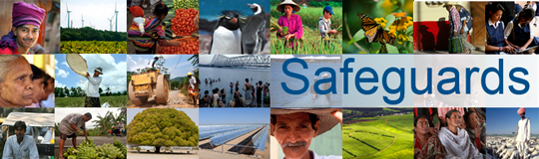
The World Bank
Review and Update of the World Bank’s Environmental and Social Safeguard Policies

Consultation Meeting with Donor Agencies – Participant List
Date: April 1, 2013

Venue: Colombo, Sri Lanka

Total Number of Participants: 7

No. | Participant Name | Organization Represented [NAME] | Organization Type  [Gov’t, private sector, foundation, NGO, union, association, think tank, academia, multilateral, IFI, bilateral agency] | Country
1 | Jayaratne Perera | Asian Development Bank (ADB) | Multilateral | Sri Lanka
2 | Seiji Noda | Asian Development Bank (ADB) | Multilateral | Sri Lanka
3 | Ao Harumi | Japan International Cooperation Agency (JICA) | Government | Sri Lanka
4 | Winnie Lau | US Agency for International Development (USAID) | Government | Sri Lanka
5 | Nihani Riza | US Agency for International Development (USAID) | Government | Sri Lanka
6 | Ignacio Oliver Cruz | Delegation of the European Union to Sri Lanka and the Maldives (EU) | Government | Sri Lanka
7 | Jaime Royo Olid | Delegation of the European Union to Sri Lanka and the Maldives (EU) | Government | Sri Lanka

