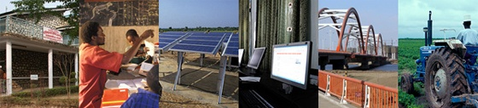
The World Bank

Procurement Policy Review

Participant List
Date: September 18, 2014

Location (City, Country): Brussels, Belgium

Total Number of Participants: 13

No. | Participant Name | Organization
1 | Elisa Bruno | European Citizen Action Service
2 | Peter De Franceschi | ICLEI
3 | Bart De Laere | Denys NV
4 | Bart De Smedt | Denys NV
5 | Martin Haase | ADRA EU Liaison Office
6 | Jeroen Kwakkenbos | Eurodad
7 | Fernando Lasheras | Iberdrola
8 | Johan Malin | Flanders Investment & Trade
9 | Walter Mondt | Ecorem nv
10 | Sargon Nissan | Bretton Woods Project
11 | Mark Perera | Transparency International
12 | Desislava Stoyanova | Friends of the Earth Bulgaria
13 | Bodo Elmers | Eurodad

