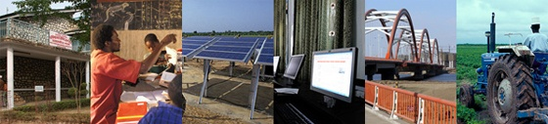
The World Bank

Procurement Policy Review

Participant List
Date: November 20, 2014

Location (Country): Tajikistan

Total Number of Participants: 26

No. | Participant Name | Organization | Country
1 | Shukurov Farkhod | Barqi Tojik | Tajikistan
2 | Irmatov Daler |  | Tajikistan
3 | Ziyoratsho Boyakov | Account Chamber of the RT | Tajikistan
4 | Firuz Tavaraliev |  | Tajikistan
5 | Sipinyorova Rukhsora | Municipal Infrastructure development Project (AF) | Tajikistan
6 | Hamrakulova Umeda | Municipal Infrastructure development Project (AF) | Tajikistan
7 | Tursoon-zadeh Farzon | Project health services | Tajikistan
8 | Gafforova Zulfia | HSIP | Tajikistan
9 | Rakhmatulloeva Kh | TARP | Tajikistan
10 | Saidkhojaev O | TARP | Tajikistan
11 | Hasanov U. | ME RT | Tajikistan
12 | Saliev Sukhrob | ME RT | Tajikistan
13 | Bekmatov Bozorali | Ministry of Economic Development and Trade
14 | Khabirov M. | PRKSZ | Tajikistan
15 | Temirov Hasan | PO “Rushdi Dehot” | Tajikistan
16 | Kudratov I. | DWSP 2 | Tajikistan
17 | Bazarova S. | WB | Tajikistan
18 | Marufov A. | MOH | Tajikistan
19 | Mukhtorov M. | SSNSP MOH | Tajikistan
20 | Bobiev A. | MofES RT | Tajikistan
21 | Kurbonova S. | ELMKLP | Tajikistan
22 | Makhmudov Z | ELMKLP | Tajikistan
23 | Bazarova S. | WB | Tajikistan
24 | Dilshod Karimova | WB | Tajikistan
25 | Sobir Kurbanov | WB | Tajikistan
26 | Shoira Zukhurova | WB | Tajikistan

