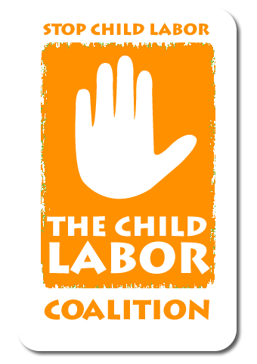
Child Labor Coalition
1701 K Street, N.W., Suite 1200, Washington, D.C. 20006
Phone: 202.207.2820 Email: reidm@nclnet.org
www.stopchildlabor.org

April 29, 2013

Dr. Jim Yong Kim President
The World Bank 1818 H St, NW
Washington, DC 20433

Dear Dr. Kim,

The Child Labor Coalition (CLC), representing millions of Americans, including teachers, workers, consumer advocates and human rights activists, is committed to reducing global poverty and the number of children involved in child labor that harms their health or development. We write to you today to ask the World Bank to address the needs of children in the bank’s safeguard policies, currently under review.

Current World Bank safeguard policies for investment lending lack explicit protections for children and their unique needs. We feel it’s critical that borrowers be required to assess the impact that proposed projects may have on children and that prohibitions on child labor be included as part of a labor safeguard requiring compliance with core labor standards. Without such an assessment, there is often no examination or analysis of the risks that such projects may pose to children and working families. Similarly the absence of a labor safeguard results in a number of Bank funded projects which directly, or indirectly, result in significant harm to these most vulnerable members of society.

The CLC collaborates closely with the Global Campaign for Education, which works to ensure that the world’s 61 million out-of-school youth are allowed access to schools. The World Bank itself has reiterated that investing in children is the clearest path to eradicating poverty. The Bank has noted that “since capacities built during childhood and the youth period largely determine adult outcomes, effective investments in young people provide important returns not only to the individual and the community, but to society as a whole.”

The CLC believes that lack of access to education forces children into child labor; combined, these two phenomena create generational poverty that the World Bank is trying to eradicate. We fear that without a labor safeguard, World Bank projects will continue to indirectly impact access to schools. Additionally, without specific protections for children resettled as a result of Bank projects, these children continue to be particularly vulnerable to exploitative employment and to losing crucial time in school.

The CLC is also very concerned about the increased risk of experiencing violence, trafficking or sexual exploitation when boom towns are created around mines or construction projects. The negative public health consequences of mining, power plants, and other development projects that may leach harmful chemicals into the air and water is another concern.

We believe that there is an urgent need for safeguards that will protect children.

The new safeguards must, at a minimum, require environmental and social impact assessments that specifically contain an assessment of the likely impacts of a project on children, including the potential for violence and exploitation that can arise around a project's implementation. Assessments of the risks to children should also consider the potential for projects to have disparate impacts based upon gender.

Language requiring attention to the unique needs of children should be added to all relevant safeguard policies, including the involuntary resettlement policy, with particular attention paid to uniquely vulnerable children, including girls and children with disabilities. A new labor safeguard should be added, and the labor safeguard should clearly prohibit child labor and require respect for fundamental labor rights, as defined by the ILO, by all companies involved in the project, as well as their supply chains and related services. Speaking on the issue of child labor, the UN Special Envoy for Global Education stated “[i]t is vital that heads of UN agencies and international financial institutions must ensure that their organizations are part of the solution, and not part of the cycle of indifference that traps so many children in exploitative employment.”
Eradicating poverty begins with children, and including protections for their security and development in the revised Safeguard policies is a necessary step toward achieving the Bank’s goal of a world without poverty.

Thank you for your time and attention to this crucial issue.

Sincerely,

Reid Maki
Reid Maki
Coordinator, Child Labor Coalition

