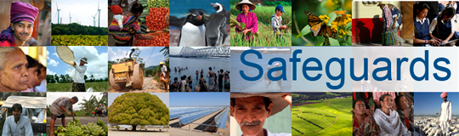
Review and Update of the World Bank’s Environmental and Social Safeguard Policies
Consultation with Private Sector Representatives
Hosted by Export Development Canada
Ottawa, Canada
January 22, 2013

This consultation meeting with private sector representatives was hosted by Export Development Canada. Welcoming remarks were made by Deborah Berger, Director of Export Development Canada. The meeting was chaired by Mr. Jonathan Rothschild, Senior Advisor to the Canadian Executive Director. Ms. Motoko Aizawa of the Safeguards Review and Update Consultation Team represented the World Bank. Ms. Aizawa provided a brief overview of the scope, objectives, and timeline of the Safeguards review and update process.
Comments and questions from participants included the following:
- In the context of safeguards, regulatory burden is a major issue, in particular in the natural resources sector. Rather than adding yet another framework, the World Bank should aim to create flexibility and benefits for compliance.
- Tailored capacity building and the use of country systems are both important for effective safeguards. The World Bank should ensure that country capacity is built sustainably. The World Bank should support the development of country systems on the basis of accepted practice. Safeguard requirements need to be internalized by countries, not only applied in specific projects. This requires capacity building, in particular with regard to governance, and attitude change. Capacity building should focus on building partnerships between donor and borrower countries.
- Safeguard policies should be accompanied by clear guidance on how they should be implemented, including examples of how they have been used effectively. The safeguards review should not create a new system from scratch, but rather learn from systems that already exist.
- Safeguards should not detract nor impede investment. Proponents need to have a certain degree of predictability regarding timing and resources in order to assure compliance with safeguard requirements. The impact of safeguards on the investment climate in a country needs to be considered.
- Participants called for stronger harmonization with other major lenders and asked that the World Bank create a flatter, less compartmentalized safeguards structure.
- The World Bank should consider thresholds below which safeguards would not need to be applied.
- The current safeguard policies are focused on compliance, but there is little monitoring and supervision after a project was approved.
- Compared to IFC’s Performance Standard, the World Bank needs to be aware that there are differences between the public and private sectors.
- Biodiversity and ecosystem services have become a major challenge in development. The World Bank’s Safeguards Review should take these issues into account.
- Consultations should be required early in projects, ideally at concept stage, so that problems can get resolved early.

