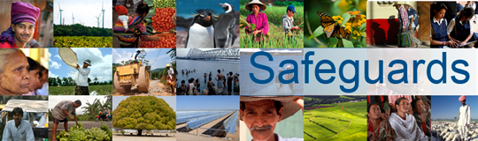
The World Bank
Review and Update of the World Bank’s Environmental and Social Safeguard Policies

Consultation Meeting (20 March, 2013) – List of Participants
Venue: Tbilisi, Georgia

No. | Participant Name | Title | Organization Represented
 | Kakha Bakhtadze | Program Manager | Caucasus Environmental NGO Network (CENN)
 | Tamar Mtvarelidze | Enviornmental Specialist | Caucasus Environmental NGO Network (CENN)
 | Elene Rusetski | President | Information Centre for Women
 | Dato Chipashvili | International Financial Institutions Programme Coordinator | Association Green Alternative,
 | Rusudan Simonidze | Co-Chair | Greens Movement of Georgia
 | Medgar Chelidze | Independent Expert (Eviroment) | Eviroment
 | Mariam Begiashvili | Independent Expert (Social) | Social
 | Nino Antadze | Team Leader, Energy and Enviroment | UNDP Georgia
 | Ia Dadunashvili | Development Director | Internews Georgia
 | Eka Beridze | Project Manager | Internews Georgia
 | Nana Lobjanidze | Communications Officer | Tansparency International Georgia
 | Alexaqndre Arobelidze | Independent Environment Consultant | N/A
 | Paata Shanshiashvili | In-Country Coordinator for Georgia International Technical Assistance Program | U.S. Depatment of Interior (USDOI)

