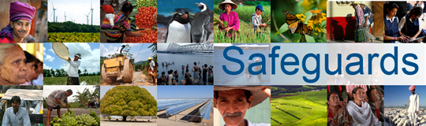
World Bank Safeguards Review and Update
Consultation Meeting with Civil Society Representatives
Ottawa, Canada, 22 January 2013
PARTICPANTS LIST
Hosted and organized by: North-South
Total Number of Participants: 18

 | First Name | Last Name | Organization
1 | Diane | Beckett
2 | Shishir | Shahnawaz | North-South Institute
3 | Shannon | Kindornay | North-South Institute
4 | Peter | Gillespis | Halifax Initiative
5 | Riccardo | Rossi-Ricci
6 | Joe | Ingram | North-South Institute
7 | Derek | MacCuish | Social Justice Committee Montreal
8 | Arpi | Hamalian | Concordia
9 | William | David | Association of First Nations
10 | Carole | Willans | International Federation of Hard of Hearing People
11 | Errol | Mendes | University of Ottawa
12 | Mark | Fried | Oxfam Canada
13 | Varena | Ushie | North-South Institute
14 | Nathan | Bowers-Krishnan | North-South Institute
15 | Dina | Shadid | North-South Institute
16 | Vangelis | Nikias | Council of Canadians with Disabilities
17 | Robert | Corbeil | Canadian Hard of Hearing Association
18 | Steven | Kuhn | Finance Canada

