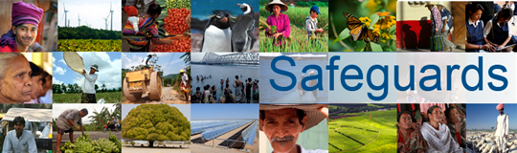
Review and Update of the World Bank’s Environmental
and Social Safeguard Policies
Participant List

Country: South Africa
Date of Meeting: February 19, 2013
Total Number of Participants: 12
Participant Name | Participant Surname | Organization
- Daniel | Prah | SANGOCO
- Jabulane | Blose | DPSA
- Frederick | Kusambiza | PlANACT
- Thabileng | Mothabi | SPII
- Puseletso | Madumise | SANGOCO
- Samuel | Baka | SANGOCO
- Lesley | Masters | IGD
- Lindiwe | Mokate | SAHRC
- Bheki | Ndaba | SANGOCO
- Vanessa | Dos Santos | DSSA/IDA
- Enoch | Peprah | Preprah & Associates
- David | Kode | CIVICUS

