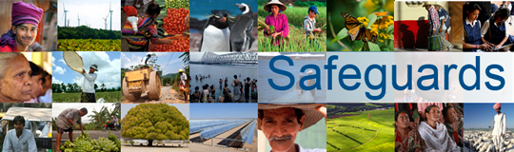

The World Bank
Review and Update of the World Bank’s Environmental and Social Safeguard Policies
Side Event of the Land and Poverty Conference

Consultation Meeting Participant List
Date: April 12, 2013

Total Number of Participants: 13

N. | Name | Organization
1 | Gregory Kitt | Norwegian Refugee Council
2 | Alexandre Corriveau-Bourque | RRI
3 | David Pred | IDI
4 | Natalie Bugalski | IDI
5 | Sasanka Thilakasiri | OXFAM
6 | Jessica Evans | Human Rights Watch
7 | Hana Heineken | Global Witness
8 | Megan MacInnes | Global Witness
9 | Jessie Connell | University of Sydney
10 | Emily Joiner | IAP
11 | Stephen Jonckheere | IFAD
12 | Gaia Larsen | World Resources Institute
13 | John Bruce | LADSI Inc.

