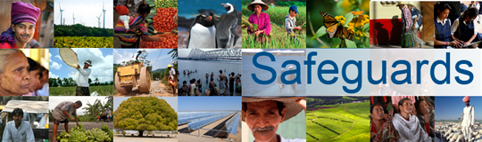
Review and Update of the World Bank’s Environmental and Social Safeguard Policies
Phase 3

Expert Focus Group on Religious Concerns and Considerations

Participant List

Date: March 8, 2016
Location: Washington, DC, USA
Audience: Expert Focus Group
Total Number of Participants: 10

No. | Participant Name | Organization/Position | Country
1 | Andrew Baker | Director of International Jewish Affairs, American Jewish Committee | United States
2 | Bishop Angaelos | General Bishop, Coptic Orthodox Church in the United Kingdom | United Kingdom
3 | Daniel Perell | Baha’i International Community, United Nations Representative | United States
4 | Dave Robinson | World Vision International | United States
5 | Harry Samuels | Government Affairs Associate, American Jewish World Service | United States
6 | Katherine Marshall | World Faiths Development Dialogue | United States
7 | Mohamed Ashmawey | Former CEO of Islamic Relief Worldwide | United Kingdom
8 | Mohamed Elsanousi | The Network for Religious and Traditional Peacemakers | United States
9 | Peter Mandaville | U.S. Department of State, Office of Religion and Global Affairs | United States
10 | Vinya Ariyaratne | General Secretary, Sarvodaya Shramadana Movement | Sri Lanka

