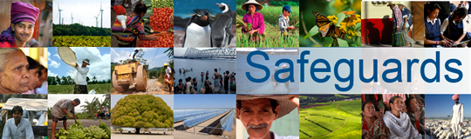
Review and Update of the World Bank’s Environmental and Social Safeguard Policies

Phase 3

Participant List

Date: November 30, 2015
Location: Pretoria, South Africa
Audience: Government
Countries connected by videoconference: None
Total Number of Participants: 9

No. | Participant Name | Organization/Position | Country
1 | Shakhira Parker | Environment | South Africa
2 | Ntsiki Mbono | Public Enterprise | South Africa
3 | Shaun Feldman | Labor | South Africa
4 | Sonnyboy Bapela | Environment | South Africa
5 | Liso Zape | Treasury | South Africa
6 | Simon Qobo | Treasury | South Africa
7 | Julie Clark | DBSA | South Africa
8 | Rhulani Baloyi | Environment | South Africa
9 | Nandi Mkuuqwana | Treasury | South Africa

