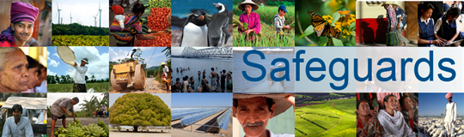
Review and Update of the World Bank’s Environmental and Social Safeguard Policies

Phase 3

List of participants

Date: January 25, 2016
Location: Rabat, Morocco
Audience: Government Officials
Total Number of Participants: 12

No. | Participant Name | Organization | Country
1 | Ouati Youssef | Department of Marine Fishing | Morocco
2 | Sbai Larbi | Department of Marine Fishing | Morocco
3 | Bensmail Laila | Department of Marine Fishing | Morocco
4 | Najia Guenouni | Ministry of Employment | Morocco
5 | Hind El Maataoui | Caisse pour le Financement Routier | Morocco
6 | Abdallah Bahassi | ONEE | Morocco
7 | Abdellatif Lahmimi | Ministry of National Education | Morocco
8 | Amal Belaud | MEAS | Morocco
9 | Mohammed Karara | METL | Morocco
10 | Kharrouj Mahdi | METL | Morocco
11 | Tabai Said | ONEE | Morocco
12 | Oucible Aaria | MEF/Budget | Morocco

