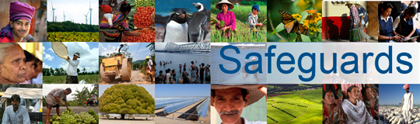
Review and Update of the World Bank’s Environmental and Social Safeguard Policies
Phase 3

High-Level Dialogue on Environmental and Social Standard 7

Participant List

Date: February 11-12, 2016
Location: Addis Ababa, Ethiopia
Audience: Expert Focus Group
Total Number of Participants: 21

No. | Participant Name | Organization/Position | Country
1 | Salvatore G. Mabiordit | Government of South Sudan | South Sudan
2 | Victoria Tauli-Corpuz | UN SRRIP | Philippines
3 | Antti Korkeakivi | UN OHCHR | Switzerland
4 | Ikal Angelei | Friends of Lake Turkana (FoLT) | Kenya
5 | Daniel Sapit | MPIDO/CRDC | Kenya
6 | Alexey Tsykarev | EMRIP | Russia
7 | James Anaya | University of Arizona | United States
8 | Bahati Keranga | Government of Kenya | Kenya
9 | Inganji Yakhama | Government of Kenya | Kenya
10 | Margaret Mwakima | Government of Kenya | Kenya
11 | Gideon Gathaara | Government of Kenya | Kenya
12 | Ben Chikamai | Government of Kenya | Kenya
13 | Albert Bar ME |  | Democratic Republic of Congo
14 | Sayed M.A. Hamadani | Ministry of Finance | Sudan
15 | Dr. Omer Mustafa E. Khidir | Ministry of Environment | Sudan
16 | Florens Marfin Turuka | United Republic of Tanzania | Tanzania
17 | Servacius B. Likwelile | Tanzania MF | Tanzania
18 | Moses Mabior Deu | MoE EP | South Sudan
19 | Fisseha Aberra | Ministry of Finance & Economic Cooperation | Ethiopia
20 | Richard Lesiyampe | Ministry of Agriculture | Kenya
21 | H.E. Ato Ahmed Shide | MoFED | Ethiopia

