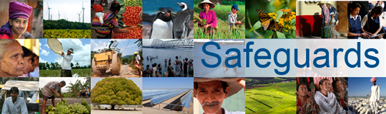
Review and Update of the World Bank’s Environmental and Social Safeguard Policies

Phase 3

List of participants

Date: November 24, 2015
Location: Riyadh, KSA
Audience: Multi-stakeholder
Total Number of Participants: 11

No. | Participant Name | Organization/Position | Country
1 | Lama Alsharif | CEO, Shababuna | KSA
2 | Ghadah Aldakheel | Human Development Expert (Childhood Development - Women Empowerment), Project Department, AGFUND | KSA
3 | Sarah Al Otaibi | Co-Founder, LelKheir | KSA
4 | Farah Alsweel | Trainee, UNDP | KSA
5 | Dr. Hana Omar | MoFA | KSA
6 | Maha Abahussain | VP, Tasamy | KSA
7 | Ahmed Alsowailem | Assistant General Security, Chamber of Commerce | KSA
8 | Nabil Haburamman | Consultant, KSCDR | KSA
9 | Yusuf Felemban | Warif Branches, Warif | KSA
10 | Bader Alasmi | Legal, GCC | KSA
11 | Atallah Alkhozaim | Warif | KSA

