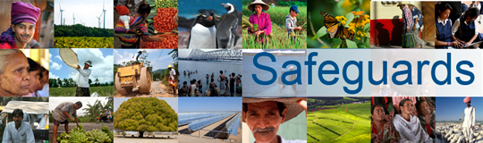
Review and Update of the World Bank’s Environmental and Social Safeguard Policies

Phase 3

List of participants

Date: December 13, 2015
Location: Beirut, Lebanon
Audience: Ministries, Municipalities, Implementing agencies & CSOs from Iraq & Jordan
Total Number of Participants: 18

No. | Participant Name | Organization/Position | Country
1 | Tanya Jumaa Raady | Women & Children | Iraq
2 | Jalil Khaleel Al Rubaye | Al Noor | Iraq
3 | Maher Mahmood Naser | ADED | Iraq
4 | Majed Shiah Thijeel | Abnaalnazeineen | Iraq
5 | Mustafa Nasser | Press Freedom Advocacy Association | Iraq
6 | Salam Qadir Haji | Ministry of Planning/Kurdistan | Iraq
7 | Mazin Kamil Alwan | R.V.T.O/Reconstruction Fund | Iraq
8 | Hidayat Abubaker Abdulrahman | Ministry of Planning/Kurdistan | Iraq
9 | Mae Al-Mulla Hussain | Ministry of Finance/Debt Department | Iraq
10 | Saleh Al Ouran | Director of Environment & Climate Change/ Ministry of Water & Irrigation | Jordan
11 | Suha Shishani | Head of Environmental projects/Greater Amman Municipality | Jordan
12 | Izzat Abou Humra | Director of Licensing & Pollution Prevention Directorate/Ministry of Environment | Jordan
13 | Mohammed Daghash | Head of Energy & Environment Division/Ministry of Energy & Mineral Resources | Jordan
14 | Imad Issa | Consultant/Ministry of Municipal Affairs | Jordan
15 | Ola Arafat | Environmental Engineer/Ministry of Social Development | Jordan
16 | Marwa Al Arabiyyat | Economic Researcher/Ministry of Social Development | Jordan
17 | Khaled Soudi | Head of Environment & Green Building Sec./Ministry of Public Works & Housing | Jordan
18 | Khaled Al-Khresha | Hashemite Fund for Development of Jordan Badia | Jordan

