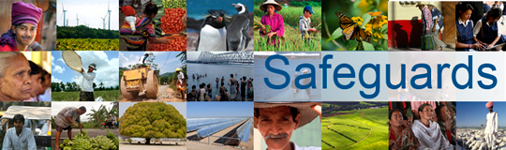
Review and Update of the World Bank’s Environmental and Social Safeguard Policies

Phase 3

Participant List

Date: December 1, 2015
Location: Pretoria, South Africa
Audience: Civil Society Organizations
Countries connected by videoconference: None
Total Number of Participants: 9

No. | Participant Name | Organization/Position | Country
1 | Makoma Lekalakala | Earthlife Africa | South Africa
2 | Mariette Liefferink | Federation for Sustainable Environment | South Africa
3 | Melita Steele | Greenpeace Africa | South Africa
4 | Anand Prabhu | Greenpeace Africa | South Africa
5 | Kevin McCann | Wildlands Conservation Trust | South Africa
6 | Palesa Madi | Center for Applied Legal Studies | South Africa
7 | Avani Singh | Legal Resources Center | South Africa
8 | Caitlin Conyers | Legal Resources Center | South Africa
9 | Tshepo Tshipa | Earthlife Africa | South Africa

