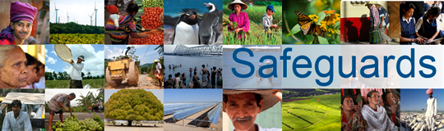
Review and Update of the World Bank’s Environmental and Social Safeguard Policies

Phase 3

List of participants

Date: February 16, 2016
Location: Tegucigalpa, Honduras
Audience: Multi-stakeholder
Total Number of Participants: 29

No. | Participant Name | Organization/Position | Country
1 | Luis Alfredo Rivas | MiAmbiente, Subsecretaria de Energía | Honduras
2 | Roger Hernández | COMRURAL | Honduras
3 | Alejandra Hernández | COMRURAL | Honduras
4 | Francis Yolanda Argeñal | IDECOAS | Honduras
5 | Carlos Cordero S. | COPECO | Honduras
6 | Odessa Fraño M. | COPECO | Honduras
7 | Victor Ponce | PIR-FHIS | Honduras
8 | Juan José Urquiza M. | DGIP-SEFIN | Honduras
9 | Mauricio Díaz Burdett | FOSDEH | Honduras
10 | Ismael Zepeda | FOSDEH | Honduras
11 | Wilfredo Cervantes | Caritas | Honduras
12 | Anabella Sibrián | Plataforma Internacional | Guatemala
13 | Donaldo Allen | MASTA/CONPAH | Honduras
14 | Marlon Pineda | CNA | Honduras
15 | George Redman | Oxfam | Honduras
16 | Hedme Castro | ACI PARTICIPA | Honduras
17 | Marlon Ochoa | FIAN Honduras | Honduras
18 | Ricardo Rivera |  | Honduras
19 | Carmen Lopez | MOPAWI | Honduras
20 | Mabel Hernández | TROCAIRE | Honduras
21 | Luis Eduardo Alvarenga | UPNFM | Honduras
22 | Emilio Gabriel Esbeih | U-ESNACIFOR | Honduras
23 | Edwin Alvarez Morales | ODECO | Honduras
24 | Raf Flores | FOSDEH | Honduras
25 | Fredis Mateo Aguilar | UPNFM | Honduras
26 | Norvin Goff | MASTA | Honduras
27 | Félix Daniel Gómez | OHCHR | Honduras
28 | Adelina Vasquez | Centro de Desarrollo Humano (CDH) | Honduras
29 | Santiago Flores Rosales | MASTA | Honduras

