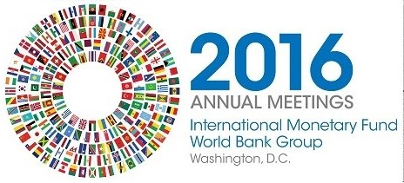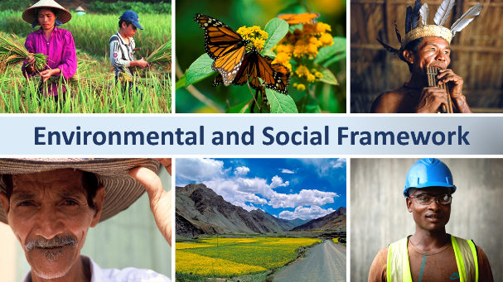
The New World Bank Environmental and Social Framework: Opportunities and Challenges for Implementation

Civil Society Policy Forum – World Bank/IMF Annual Meetings 2016

Participant List

Date: October 7, 2016
Location: Washington, DC, USA (with livestream)
Total Number of Participants: 55 (including 1 moderator and 3 panelists)

No. | Participant Name | Organization | Country
1 | Elana Berger | Bank Information Center (BIC) | United States
2 | Carla García Zendejas | Center for International Environmental Law (CIEL) | United States
3 | Jon Richart | Millennium Challenge Corporation (MCC) | United States
4 | Kelsey Alford-Jones | Center for International Environmental Law (CIEL) | United States
5 | Annabel Perreras | International Accountability Project (IAP) | United States
6 | Knud Voecking | Urgewald | Germany
7 | Benito Calixto Guzmán | Foro Indígena del Abya Yala (FIAY) | Peru
8 | Alex Mourant | U.S. Environmental Protection Agency (EPA) | United States
9 | Karen Travis | U.S. Department of Labor | United States
10 | Elizabeth Summers | Bank Information Center (BIC) | United States
11 | Christine Andela | Collectif des ONG pour la Sécurité Alimentaire et le Développement Rural (COSADER) | Cameroon
12 | Leonardo A. Crippa | Indian Law Resource Center | United States
13 | Jeff Baker | Senior Advisor to Executive Director, Office of the Executive Director, United States (EDS01) | United States
14 | Patricia Quijano | American University Washington College of Law | United States
15 | Kisha Nicolas | The African Methodist Episcopal Church Service and Development Agency (AME-SADA), Inc. | United States
16 | Kindra Mohr | Accountability Counsel | United States
17 | Shewaferahu Kuratu | African Peace Mediation and Reconciliation Institution | United States
18 | Wunna Htun | Bank Information Center (BIC) | Myanmar
19 | Agha Mohsin Ali | Creative Associates International | United States
20 | Alyssa Beccar | Center for International Environmental Law (CIEL) | United States
21 | Devan Brown | Center for International Environmental Law (CIEL) | United States
22 | Bama Athreya | U.S. Agency for International Development (USAID) | United States
23 | David Fulton | George Mason University | United States
24 | Amir Lakha | Humanitarian and Charitable ONE Trust (HACOT) | United Kingdom
25 | Pieter Jansen | Both ENDS | The Netherlands
26 | Umidjon Ulugov | NGO “Globe” Tajikistan | Tajikistan
27 | Akbar Khawaja | P.T.F. | Pakistan
28 | Richard Jordan | The Royal Academy of Science International Trust (RASIT) | United States
29 | Natalia Camacho Monge | Consejo Nacional de la Persona Joven (CPJ) | Costa Rica
30 | Felix Anderl | Goethe University Frankfurt | Germany
31 | Radek Stech | University of Exeter Law School | United Kingdom
32 | Moses Ntenga | Joy for Children | Uganda
33 | Stephanie Amoako | Accountability Counsel | United States
34 | Suyoung Kim | Atlas Corps | United States
35 | Gabriela Stocks | U.S. Department of State | United States
36 | Shokoufeh Rahbar | LLM student at GW Law | United States
37 | Max Malterer | AIESEC International | Germany
38 | Leo Baunach | International Trade Union Confederation | United States
39 | Mathias Lyamunda | Foundation for Environmental Management and Campaign Against Poverty (FEMAPO) | Tanzania
40 | Amy Van Zanen | Gender Action | United States
41 | Elaine Zuckerman | Gender Action | United States
42 | Korinna Horta | Urgewald | Germany
43 | Ishita Petkar | Human Rights Watch | United States
44 | Joseph Graziano | U.S. Department of Defense Office of Inspector General | United States
45 | Siti Aminah | Indonesian Legal Resource Center | Indonesia
46 | Mondonga M. Mokoli | Strayer University | United States
47 | Jean-Pierre Alumba Lukamba | African Diaspora Forum | South Africa
48 | Rosina Akourkor Teye | Dolly Foundation | Ghana
49 | Muhammad Al Amin | Wahana Lingkungan Hidup Indonesia (WALHI) | Indonesia
50 | Rachel Bayly | U.S. Department of the Treasury | United States
51 | Sonia Zilberman | Crude Accountability | United States
52 | Faith Nwadishi (Moderator) | Founder & Executive Director, Koyenum Immallah Foundation | Nigeria
53 | Michele de Nevers (Panelist) | Senior Associate, Center for Global Development (CGD) | United States
54 | William (Bill) Vincent Kennedy (Panelist) | Director, Office of Accountability at U.S. Overseas Private Investment Corporation (OPIC) | United States
55 | Yahia Abdalrahman Elmahadi (Panelist) | Managing Director, Sudanese Development Initiative (SUDIA) | Sudan

