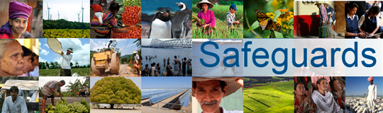
The World Bank
Review and Update of the World Bank’s Environmental and Social Safeguard Policies

National Dialogue with Indigenous Peoples in the Philippines
Date: November 5, 2013

Venue: Manila, Philippines

Total Number of Participants: 19

No. | Name | Group/Organization Represented
1 | Florence Umaming | Kankanaey
2 | Peter Cosolan | Ibaloi
3 | Inocencio Carganilla | Bago
4 | Janifer Baquiran | Calinga
5 | Arman Ancheta | Agta
6 | Salvador Dimain | Aeta
7 | Victoriano Colili | Palaw’an
8 | Nimfa Alina | Agta Tabangon
9 | Rene Trono | Bukidnon Magahat
10 | Lolita Tizon | Bukidnon
11 | Datu Masid Yacob | Yakan
12 | Datu Mangura Dr. J | Subanen
13 | Datu Jemuel Perino | Umayamnon
14 | Datu Elfranco Linsahay | Talaandig
15 | Hon. Imelda Signapan | B’laan
16 | Datu Caleasa Katug | T’boli
17 | Datu Jaime Odo | Bagobo-tagabaua
18 | Elewterio Manaytay | Mandaya
19 | Atty. Lee Arroyo | National Commission on Indigenous Peoples (NCIP)

