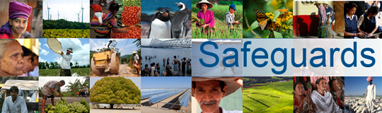
The World Bank
Review and Update of the World Bank’s Environmental and Social Safeguard Policies

Dialogue Meeting with the Abya Yala Technical Committee (Latin American and the Caribbean Indigenous Network)
Date: November 25-27, 2013

Venue: Washington, DC, United States

Total Number of Participants: 8

No. | Name | Organization Represented
1 | Florina Lopez | Abya Yala Technical Committee
2 | Jenny Aguirre | Abya Yala Technical Committee
3 | Johnson Cerda | Abya Yala Technical Committee
4 | Jose Antonio Medina | Abya Yala Technical Committee
5 | Maria Eugenia Choque | Abya Yala Technical Committee
6 | Onel Masardule | Abya Yala Technical Committee
7 | Ramiro Batzin | Abya Yala Technical Committee
8 | Rodrigo de la Cruz | Abya Yala Technical Committee

