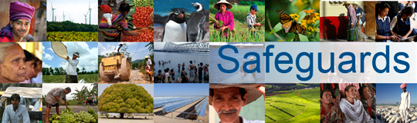
Review and Update of the World Bank’s Environmental and Social Safeguard Policies
Phase 2

Participant List
Date: November 3, 2014
Location: Beirut, Lebanon
Audience: Civil Society Organizations
Total Number of Participants: 19

No. | Participant Name | Organization/Position | Country
1 | Lea Bou Khater | CRI | Lebanon
2 | Maha Jammoul | CESD | Lebanon
3 | Yara Akkari |  | Lebanon
4 | Elias Achkar | Association of Banks in Lebanon | Lebanon
5 | Ralph Stephan | Kafalat SAL | Lebanon
6 | Ronald Barakat | Lebanese Transparency Association (LTA) | Lebanon
7 | Nadine Ismail | The Learning Center for the Deaf + DPI | Lebanon
8 | Amer Makarem | Youth Association of the Blind (YAB) | Lebanon
9 | Samer El Safah | Makhzoumi Foundation | Lebanon
10 | Samir Traboulsi | American University of Beirut/ASHRAE | Lebanon
11 | Alicia Jammal | Information International | Lebanon
12 | Ali Ezzeddine | Association for the Development of Rural Capacities (ADR) | Lebanon
13 | Ziad Halaby | Vitas Lebanon | Lebanon
14 | Omar Harfouch | Lebanese Medical Association for Sexual Health (LENASH) | Lebanon
15 | Ramzi Abdul-Fattah | EMKAN | Lebanon
16 | Maha Dannaj | Lebanese Down Syndrome Association | Lebanon
17 | Hassan Sherry | ANND | Lebanon
18 | Mohamad Bassam | Imam Sadr Foundation | Lebanon
19 | Sylvana Lakkis | Disabled Peoples International | Lebanon

