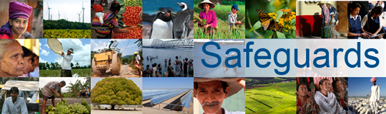
The World Bank/IMF Annual Meetings
Road-Testing the Proposed Environmental and Social Framework: Implications for Borrowers
Review and Update of the World Bank’s Environmental and Social Safeguard Policies

Phase 3

Participant List

Date: October 7, 2015
Location: Lima, Peru
Audience: Multi-stakeholder
Total Number of Participants: 45

No. | Participant Name | Organization
1 | Everlyne Nairesiae | Oxfam
2 | Jimena Eyzaguirre | ESSA
3 | Nadia Daar | Oxfam International
4 | Sarah Woods | DFAT, Australia
5 | Armand Guy Zounguere-Sokambi | BDEAC - Central African States Development Bank
6 | Marie Delphine Lemanga | BDEAC - Central African States Development Bank
7 | Rachel Grant | DFID
8 | Vladislav Michalcik | Rama Clara
9 | Rachel Burton | BIC
10 | Sarah Short | MFAT, New Zealand
11 | Barney Laseko | Prime Minister’s Office (PMO), Tanzania
12 | Harley Rodriguez Téllez | VIPFE, Ministerio de Planificación del Desarrollo de Bolivia
13 | Marcelo Z. | Bolivia
14 | Myriam Cordova | SBS
15 | Lucía Romero | SBS
16 | Javier Poggi | SBS
17 | Maria E. Sanchez | SBS
18 | Rubén Mendiolaza | SBS
19 | Emilio Benavides | SBS
20 | Oscar Orcon | MEF
21 | Luis W. | PUCP
22 | Milagros Verástegui | SENACE
23 | Nezir Sinani | BIC
24 | Chad Dobson | BIC
25 | Peter Bakvis | ITUC
26 | Stephen Pursey | ILO
27 | Rodolfo Baca | ONP
28 | Esayas Bahre | DBE
29 | J.S. Koroma | UTBL
30 | Enrique Lancho | UNOPS
31 | Carmen Bedoya | EMN
32 | Tania Sanchez Maurtua | Banco de la Nación del Perú
33 | B. Vietzke | UNICEF
34 | Bereket Simon | CBE
35 | Joe Athialy | BIC
36 | Barbara Schnell | KfW
37 | Lisa Andon | Micronesia Conservation Trust
38 | Aldo Guillén | Neutroo.com
39 | Marco Argandoña | CGR
40 | Michel Celi Vegas | ECCLA Switzerland
41 | Arturo Cruz | AGRONOTICIAS
42 | Marit Strand | Norad
43 | Meghna Shrimali | Ernst & Young
44 | Claudia Valenzuela | Ernst & Young
45 | Eduardo García Zúñiga | Agencia de Noticias Andina

