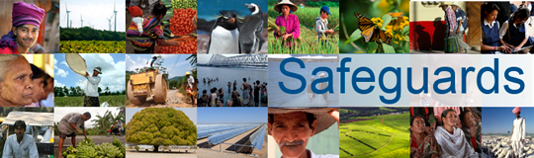
The World Bank
Review and Update of the World Bank’s Environmental and Social Safeguard Policies

Consultation Meeting with Civil Society Organizations – Participant List
Date: March 22, 2013

Location: Bucharest/Romania and Chisinau/Moldova (via video conference)

Total Number of Participants: 8

No. | Participant Name | Organization Represented | Position | Organization Type
1 | Raul Pop | Asociatia Ecoteca (Association Ecoteca) | Director of Programs | NGO
2 | Niculae Rădulescu-Dobrogea | Eco-Civica (Eco-Civic) | President | NGO
3 | Ioan Gherheş | Asociatia Romana de Mediu (Romanian Environment Association) | Executive President | NGO - Professional association
4 | Adrian Mihăilescu | Bios Impact | Director | NGO - Environmental consultancy
5 | Raluca Dan | WWF Romania | Public Policy Coordinator | NGO
6 | Valentin Bobeica | Ecological Movement of Moldova | Vice President | NGO
7 | Natalia Suruceanu | REC Moldova (Regional Environment Center) | Consultant | NGO
8 | Nicolae Ciocan | Keystone Moldova (representing the Association of People with Disabilities) | Director of Administration | NGO

