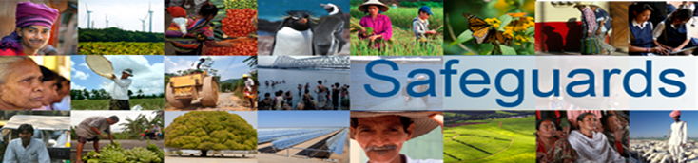

The World Bank
REVIEW AND UPDATE OF THE WORLD BANK’S ENVIRONMENTAL
AND SOCIAL SAFEGUARD POLICIES
Multi-Stakeholder Consultation Meeting
Civil Society Organizations, analytical centers (think tanks), academia, development agencies
Almaty, Kazakhstan, March 28, 2013
A multi-stakeholder meeting with representatives of civil society was held on March 28, 2013 to discuss the World Bank Safeguards review and update process. The meeting was facilitated by Zhanna Rysakova (see Annex 1 - list of participants). After a presentation by the World Bank Safeguards Review Team on the background, intended scope and process for the review, the floor was open for participants’ questions and comments. Suggestions are outlined below:

- What improvements should the Bank make on the safeguard policies to enhance their effectiveness?

- Support local authorities to follow Bank policies in purchasing lands and homes from local people;

- Should focus more on training of project personnel for qualitative and appropriate implementation of project/program requirements, as well as addressing local governance issues;

- Should improve the efficiency of protection mechanisms as well as participation and decision making procedures that involve people affected by the project at the preparation, implementation and assessment stages of the project;

- Transparency and availability of information about the Bank’s project requirements and policies for local people should be ensured;

- Independent NGOs should participate formally (rather than informally) in decision making at all stages of the project;

- OP 4.10 on Indigenous Peoples – the definition in the policy does not seem to be fully applicable in Central Asia. The rights of Indigenous Peoples should be defined as “inherent rights of local people” as it is defined in the UN Declaration on the Rights of Indigenous Peoples, but not as “interested parties;”

- Avoid making big changes or amendments to already existing good policies, and avoid generalizing content, as it may weaken the policies;

- The Bank should fundamentally change development paradigms. It must entail sustainable development, tackle problems of scarce resources considering all political, economic, financial, and environmental systems of the world;

- The government authorities and project/program implementers should provide fair/adequate compensation for land plot/house acquisitions when implementing projects under the policy on Involuntary Resettlement;

- Cooperation and dialogue with NGOs should be more efficient;

- The Bank should take more responsibility for auditing, analyzing expenditures, and monitoring the efficiency of projects/programs at all stages of implementation;

- Seminars/training for project/program personnel on safeguard policies are needed, as is training on international standards for local authorities (akimats, state bodies);

- Training should also be provided for representatives of state bodies and the local population, focused on inclusive implementation practices. Local experts and practitioners could be involved to help achieve these objectives;

- Information on project/program requirements for environmental and social protection and remediation should be made available in the local language.

- How should the Bank better support borrower's country laws, systems and institutions?

- During implementing of projects/programs that create risks and threats to the environment, or the rights and interests of people, priority should be given to those safeguard policies, whether national or the World Bank’s, that have better protective mechanisms;

- The interests of disabled people (particularly women) should be taken into account; using sign language where necessary is important. It is also necessary to clarify how the Convention on the Rights of Persons with Disabilities could be promoted;

- The Bank should inform NGOs about its programs;

- Assistance should be provided to strengthen the legislative basis for enhancement of existing mechanisms in regional cooperation in the Aral Sea Basin, through improvement of the organizational structure and legal framework of the IFAS.

- How should the Bank and borrowers work together to improve environmental and social sustainability in borrower countries?

- During implementation of environmental projects/social assessment policies, local NGOs, people, and civic groups should be involved. Their opinion and feedback should be considered and consultations conducted;

- Strategies and policies designed for Central Asia should take into account social, economic, political, religious, and inter-ethnic issues, the need to strengthen non-governmental institutions, and provide for an inclusive approach;

- It is necessary to be consistent and harmonize with existing policies, national legislation and international agreements during project implementation;

- Should guarantee transparency of information for earmarked credit funds, for example, there is a negative experience in Kazakhstan linked with IFC participation in the Karashyganak Project, namely, complaints of violation of local people's rights, national legislation and the Aarhus Convention;

- Environmental projects/programs should be aligned with the Astana Initiative, “Green Bridge” presented at the 6th Conference of the Asian-Pacific Region;

- Special policy should be developed for Central Asian countries focused on problems of human rights, such as the calibrated approach of EBRD in cooperation with Turkmenistan;

- List of prohibited investments should be developed to include prohibited zones, for example, glacier sites, national parks, protected areas, cultural heritage sites, seismic areas, etc.;

- Geopolitical risks should be considered during decision making regarding Central Asian countries and the Caspian region. Projects with transboundary issues may escalate tensions in the region, for example, construction of Rogun Hydro Power Project and the Trans Caspian pipeline.

Annex 1
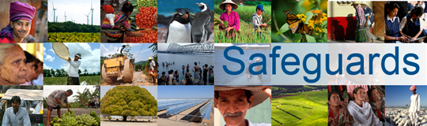

The World Bank
Review and Update of the World Bank’s Environmental and Social Safeguard Policies
Consultation Meeting – Participants List
Date: 28 March, 2013
Venue: World Bank CARO, Almaty, Kazakhstan
No. | Participant Name | Organization Represented, Title
1. | Mr. Rustam Arstanov | The Regional Environmental Center for Central Asia (CAREC),  Program Manager
2. | Ms. Galina Chernova | Globus Center of Ecological-Juridical Initiative CSO, Director
3. | Ms. Natalia Ablova | Bureau on Human Rights & Rule of Law, Dirеctor
4. | Ms. Zuriya Dussebaeva | Cooperation for Sustainable Development of Kazakhstan (CSD Center), Project Specialist
5. | Mr. Sergey Solyanik | Crude Accountability, Consultant
6. | Mr. Bauyrjan Issaliev | National Analytical Information Resource, NGO,  Deputy Chairman of the Board
7. | Mr. Yuriy Krivodanov | Blago NGO, Director, Head of Secretariat National Advisory Council transparency & sustainable development
8. | Ms. Sakan Aubakirova | Center for Rural NGOs "Birlik", Director
9. | Mr. Valeriy Zhiltsov | EcoForum, NGO, International Consultant, UNDP, GEF Renewable Energy Expert
10. | Ms. Lyazzat Kaltayeva | Association of Women with Disabilities “Shyrak”,  Central Asian Disability Forum
11. | Ms. Svetlana Ushakova | Foundation "Institute of National & International Initiatives for Development", Director
12. | Ms. Rakhat Baibolotova | Eurasian Development Bank, Senior Specialist
13. | Mr. Ardak Tashenov | Eurasian Development Bank
14. | Ms. Aigul Absametova | Eurasian Development Bank
15. | Mr. Murat Bekniyazov | International Fund for Saving the Aral Sea, Plenipotentiary Representative
16. | Ms. Zhanna Ryssakova | Facilitator

