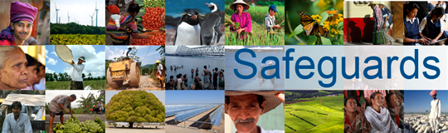
Review and Update of the World Bank’s Environmental and Social Safeguard Policies (Phase 2)

Participants List
Date: January 7, 2015
Location (City, Country): Ottawa, Canada
Audience (Government, CSO, etc.): CSO
Total Number of Participants: 12

No. | Participant Name | Organization/Position
 | William David, | Assembly of First Nations
 | Chris Roberts, | Canadian Labour Congress
 | Emily Norgang, | Canadian Labour Congress
 | Diane Beckette, | CSO Consultant
 | Ian Thomson, | Kairos
 | Daniel Wilson, | Congress of Aboriginal Peoples
 | Craig Benjamin | (Amnesty)
 | Sara Bergeron
 | Francois Louis Scylla, | CECI
 | Tara Brinston, | Inclusion International
 | Jay Drydyk, | Carleton University
 | Michelle Bested, | CCIC (Canadian Council for International Cooperation)

