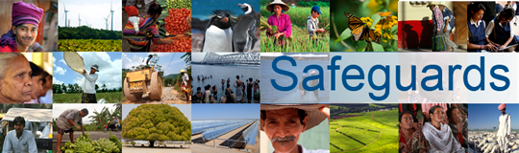
Review and Update of the World Bank’s Environmental and Social Safeguard Policies (Phase 2)

Participants List
Date: January 8, 2015
Location (City, Country): Ottawa, Canada
Audience (Government, CSO, etc.): Government
Total Number of Participants: 21

No. | Participant Name | Organization/Position
- 1 | Vaughn Lantz, | DFATD
 | Chris da Silva, | DFATD
 | Steven Weaver, | DFATD
 | Lidia Peci, | DFATD
 | Stephen Weaver, | DFATD
 | Marie-Eve Desrochers, | Finance Canada
 | Renee McKenzie, | DFATD
 | Duyai Kien | DFATD
 | Meghan Watkinson, | DFATD
 | Erica Bach, | DFATD
 | Rachael Bedlington, | DFATD
 | Emmanuelle Tremblay, | DFATD
 | Andrea Khan, | DFATD
 | Marie-France Houle, | DFATD
 | Sylvie Cote, | DFATD
 | Ron Lyen, | Natural Resources Canada
 | Ken Farr, | Natural Resources Canada
 | Nicolas Duval, | Natural Resources Canada
 | Michel Lacourciere, | Aboriginal Affairs and Northern Development Canada
 | Kathryn Fournier, | Aboriginal Affairs and Northern Development Canada
 | Vaughn Lantz, | DFATD

