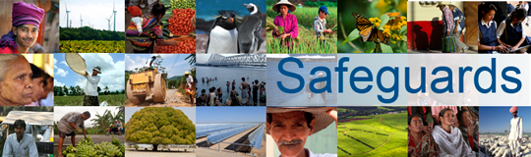
Review and Update of the World Bank’s Environmental and Social Safeguard Policies (Phase 2)

Participants List
Date: January 8, 2015
Location (City, Country): Ottawa, Canada
Audience (Government, CSO, etc.): Private Sector
Total Number of Participants: 9

No. | Participant Name | Organization/Position
 | Francois Meloche, | Batirente
 | Chris Snyder, | CBIC (Canadian Imperial Bank of Commerce)
 | Jeanette Patell, | GE Canada
 | Jim Cooney, | Independent consultant
 | Rio Tinto | (intern)
 | Norman Looker, | RJ Burnside
 | Ann Fantin, | Royal Bank of Canada
 | Claudia Schaerer, | Schaerer Consulting
 | Yolanda Banks, (hosted) | Export Development Canada

