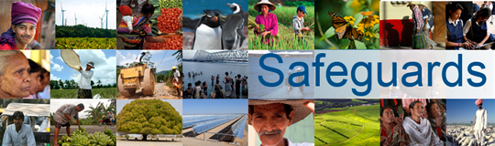

Review and Update of the World Bank’s Safeguard Policies

Consultation Meeting with Civil Society Organizations, New Delhi, 5 April 2013

Note

Following the welcome and introductory remarks by the India Country Director and Safeguards Policies Review team, the consultation meeting was interrupted by a group of about 15 members of the Delhi Solidarity Group who contested the meeting. A summary of the meeting is not available as the situation did not allow consultation participants to engage and provide input to the World Bank review of the environmental and social safeguard policies. The World Bank is grateful to those civil society representatives that attended the meeting intending to provide input to the policy review for their time and effort and for sharing their views online.

