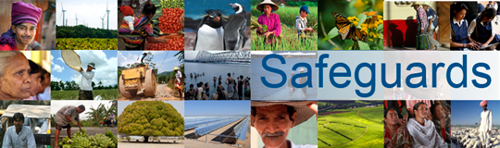
The World Bank
Review and Update of the World Bank’s Environmental and Social Safeguard Policies

Consultation Meeting – Participant List
Date: December 6, 2012
Venue: Ministry of Foreign Affairs, The Hague, The Netherlands (multiconstituency meeting)
Total Number of Participants: 14
No. | Participant Name | Organization Represented | Organization Type | Country
1 | Anouk Frank | Both Ends | NGO | Netherlands
2 | Leonie Wezendonk | Both Ends | NGO | Netherlands
3 | Alexander van den Heuvel | Amnesty International | NGO | Netherlands
4 | Pol van de Voort | 11.11.11 | NGO (Belgium) | Belgium
5 | Knud Voecking | Urgewald | NGO (Germany) | Germany
6 | Duncan Pruett | Oxfam Novib (GROW campaign) | NGO | Netherlands
7 | Harriet de Jong | Dutch Coalition on Disability and Development | NGO | Netherlands
8 | Wouter Veening | Institute for Environmental Security | Think Tank | Netherlands
9 | Leo van der Vlist | Netherlands Center for Indigenous Peoples | NGO | Netherlands
10 | Annie van Wezel | Netherlands Trade Union Confederation (FNV) | Trade Union | Netherlands
11 | Selim Iltus | Oak Foundation | NGO | Netherlands
12 | Helene Rekkers | Ministry of Foreign Affairs | Government | Netherlands
13 | Daan Marks | Ministry of Finance | Government | Netherlands
14 | Samuel Mondlane | Urgewald | NGO | Germany

