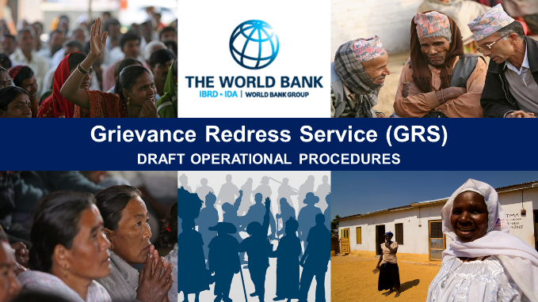
______________________________________________________________________________________________________________________________
Operational Procedures for the World Bank’s Grievance Redress Service (GRS)
Public Consultation on Draft GRS Operational Procedures: June 22, 2016 | Washington, DC
Consultation Email: grsprocedure@worldbank.org
Consultation Website: http://consultations.worldbank.org/consultation/operational-procedures-world-banks-grievance-redress-service-grs
PARTICIPANT LIST
______________________________________________________________________________________________________________________________
No. | Name | Title | Organization
1 | Kindra Mohr | Policy Director | Accountability Counsel
2 | Sarah Mirza | Policy & South Asia Law Fellow | Accountability Counsel
3 | David Hunter | Professor | American University Washington College of Law
4 | Erika Lennon | Coordinator, Program on International & Comparative Environmental Law | American University Washington College of Law
5 | Amy Ekdawi | Program Manager | Bank Information Center (BIC)
6 | Elana Berger | Child Rights Program Manager | Bank Information Center (BIC)
7 | Carla García Zendejas | Director, People, Land & Resources Program | Center for International Environmental Law (CIEL)
8 | Ann Perreras | Policy Coordinator/Smitu Kothari Fellow | International Accountability Project
9 | Peter Bakvis | Director | ITUC/Global Unions - Washington Office

