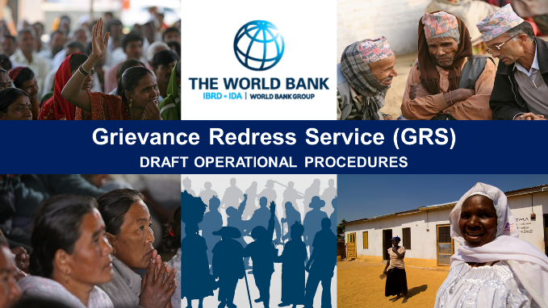
______________________________________________________________________________________________________________________________
Operational Procedures for the World Bank’s Grievance Redress Service (GRS)
Public Consultation on Draft GRS Operational Procedures: June 22, 2016 | Washington, DC
Consultation Email: grsprocedure@worldbank.org
Consultation Website: http://consultations.worldbank.org/consultation/operational-procedures-world-banks-grievance-redress-service-grs
SUMMARY
______________________________________________________________________________________________________________________________
FEEDBACK DETAILS |  | FEEDBACK SUBMITTED
No. | Subject of comments | Comments & Recommendations
1 | Timelines | - Section IV, No 25 of the GRS operational procedures:  Please clarify whether the 30 day deadline only refers to the formulation of a solution for a given complaint or also entails the requirement of a formal acceptance by the complainant?  - Discrepancies regarding the timelines in the draft procedures and the presentation were criticized. Hence, consistency should be provided to avoid confusion.
2 | Admissibility (Section II) | - Include a footnote to clarify that the GRS deals with all complaints related to World Bank funded projects.  - Lower the bar for complainants to use the GRS:  - Erase the paragraph on representation  - Erase the paragraph on anonymity  - Present the GRS as a window wide open to people to file complaints.  - One comment referred to the desirability of a complete ban of all admissibility criteria to the GRS to make the window as wide as possible.
3 | Interaction and sequencing of the GRS with other complaint mechanisms at the World Bank | - Greater clarity is needed specifying that there is no sequencing of the GRS with the PLGMs or the IPN.  - Clarify that contacting the GRS is one of the ways to meet the IPN’s requirement to attempt to contact Bank management before filing a complaint.  - Concerns were raised that the GRS might present itself as the only way to do so, which is not the case and what should be made clear.  - Be more precise on the matter that the GRS is not an alternative to the Panel but a complementary instrument.
4 | Language used in the document | - Change the language to a less legalistic one to reflect the non-bureaucratic ad-hoc interventions that the service provides.
5 | Accessibility of the GRS | - Circulate more information on which different access channels and alternative avenues exist for complainants to approach the GRS.
6 | Grievance Redress Mechanism (project-level GRMs) | - Ensure that there is no requirement reflected in the procedures or used in practice for project-affected people to go back to the project-level GRM as they might have been dissatisfied with it in the first place.  - Support the design of effective grievance redress mechanisms on the project-level.
7 | Information dissemination on the ground | - Provide enough information material to make people aware that what is happening on the ground is a World Bank funded project and aware of the corresponding avenues for grievance redress.
8 | Anti-retaliation measures | - Make sure there is a paragraph on anti-retaliation, and be specific which provisions the Bank can take to work towards protective measures for the complainant.  - If the Bank is not able to provide protection, be frank about it and include it in the operating procedures.
9 | Outcomes of the GRS process | - Include some sentences about what the desired outcomes of a successful GRS process might look like.
10 | Representation | - Include a paragraph on representation, including how local representatives can speak on behalf of individuals or a whole community.
11 | Additional questions | - What’s the problem with inadmissible complaint, i.e. why were they deemed inadmissible?  - What’s the scope of coverage of the GRS? Does it cover all World Bank funded operations?  - What’s the submission deadline for comments?  - Which services does the GRS actually provide?  - Why didn’t the GRS embrace the IFC Compliance Advisor Ombudsman model for its operating procedure?  - How are you planning to make people aware that it’s an active World Bank project they have a complaint about?  - What’s the day-to-day vision to improve GRMs on the ground?  - What is the relationship between the GRMs and the GRS? Is the GRS helping with their design?  - Do project-affected people or individuals have to get in touch with the GRM before addressing the GRS?  - What does the Bank do to improve its overall efforts to prevent retaliation and protect its complainants?

